- With scissors, cut the base off of one bottle. Try to make a nice even cut.
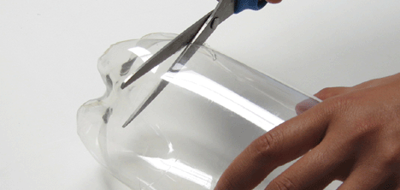

- Fit the two bottles together, lining them up to form a straight cylinder, as shown below.
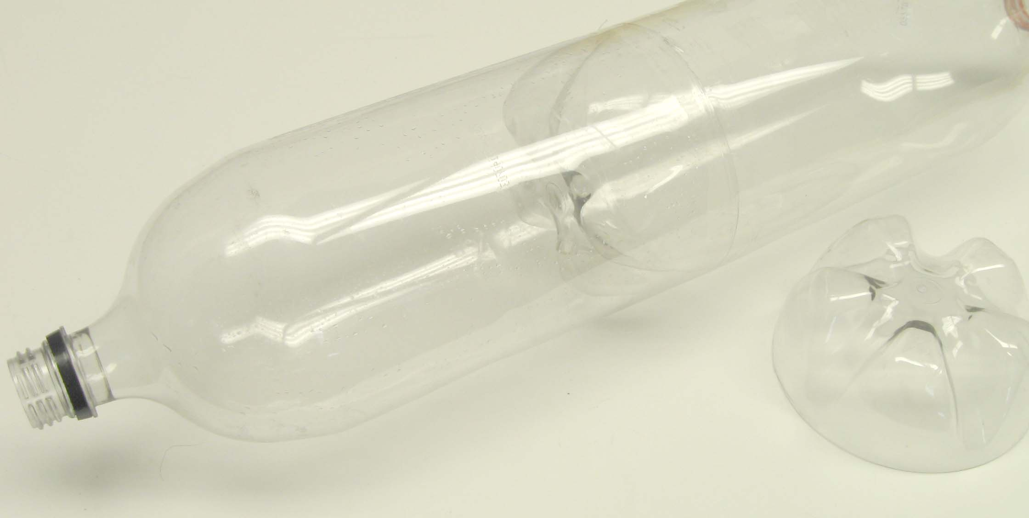

- Tape the joint between the bottles with two layers of fiberglass tape.
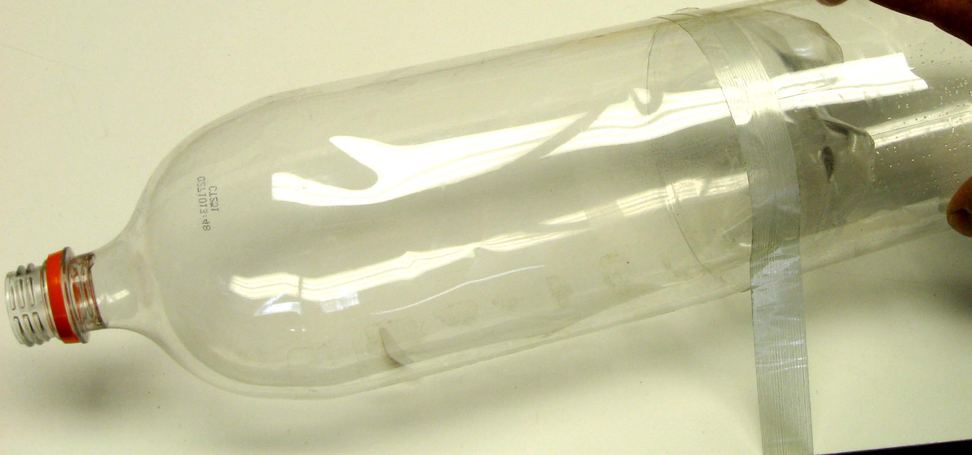

- Tape at tennis ball on top of the threaded end of the bottle.
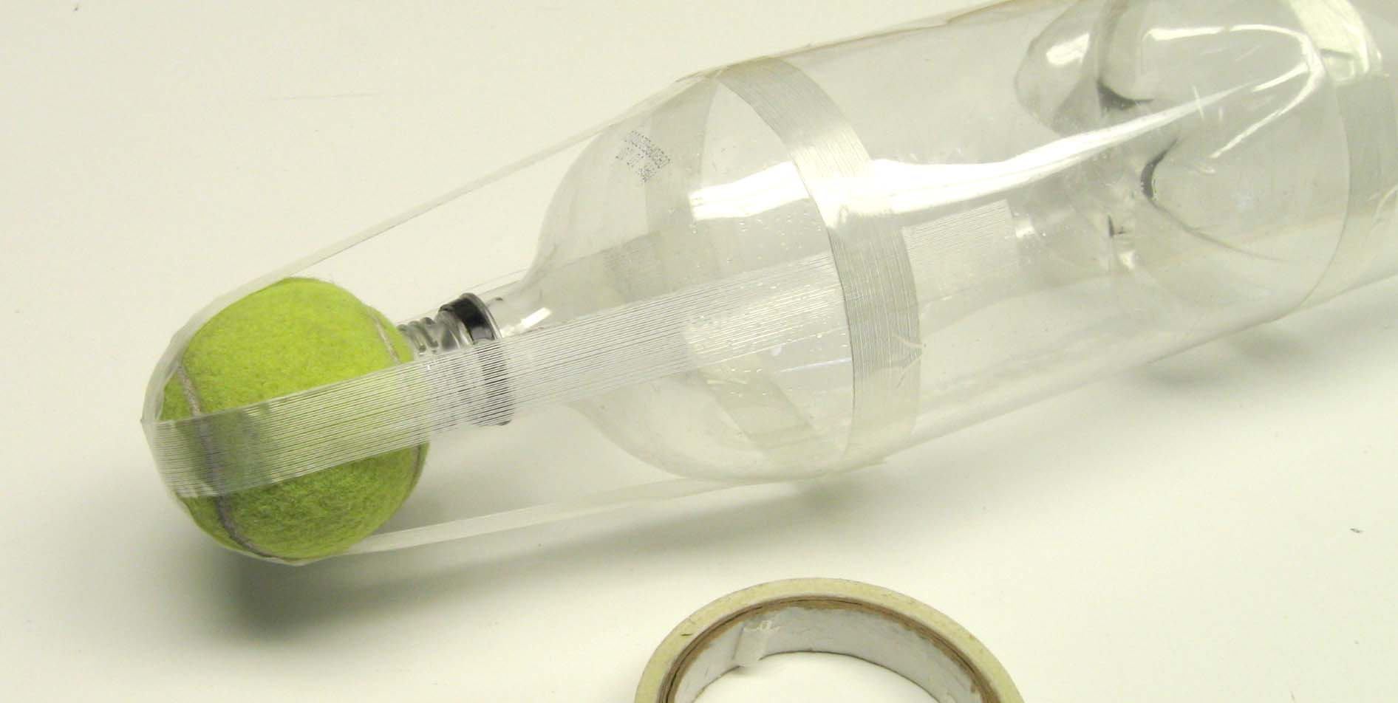
- Complete two-bottle rocket.

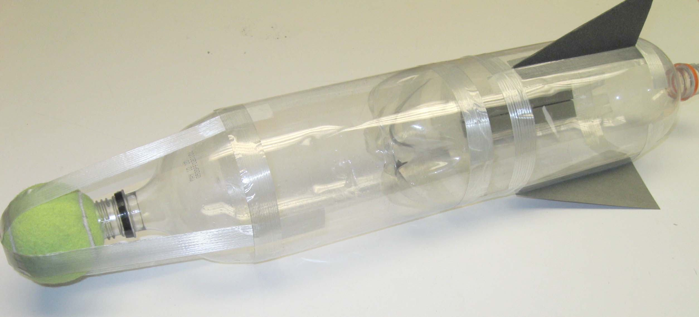

These instructions are for how to construct a two-bottle water rocket. This design slightly more difficult, but will result in a rocket that is more stable and will fly higher.

